110 E 2nd street
Howard Raymond: Lot size 11,018 square feet – 70x90 6,000 square feet building size
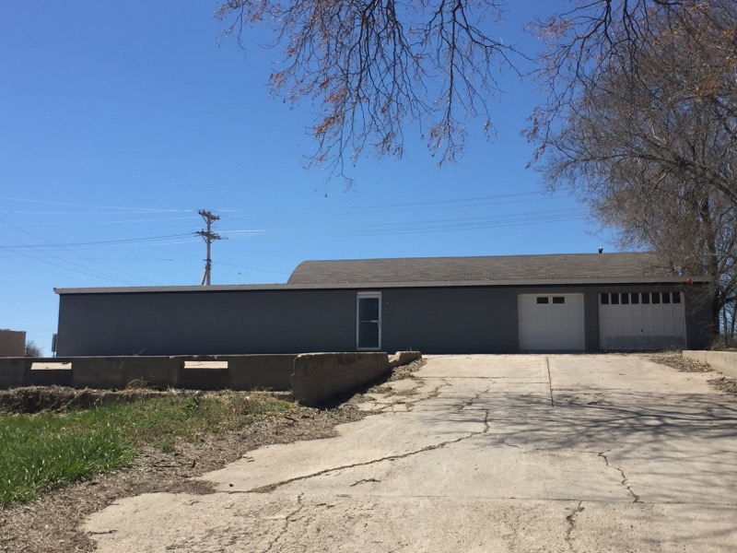

102 W 2nd street
Glenda Bierfrund - (308) 367-6527 - Lot size 7,000 square feet – building dimensions 40x23 920 square feet - Rent $300 + Utilities - Sell $20,000
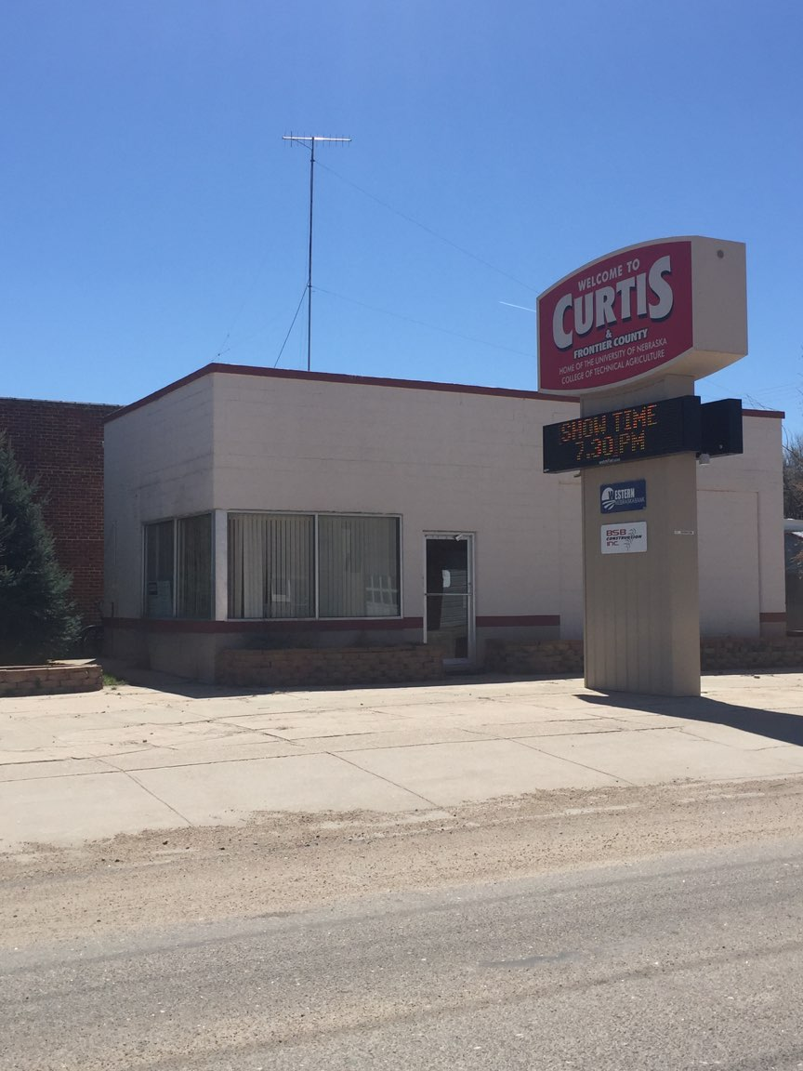

205 Center Ave
Jon Schroeder - (308) 367-7071 – lot size 2,800 Square Feet - dimensions 87x20 1,750 - Rent/Sale Price is Negotiable
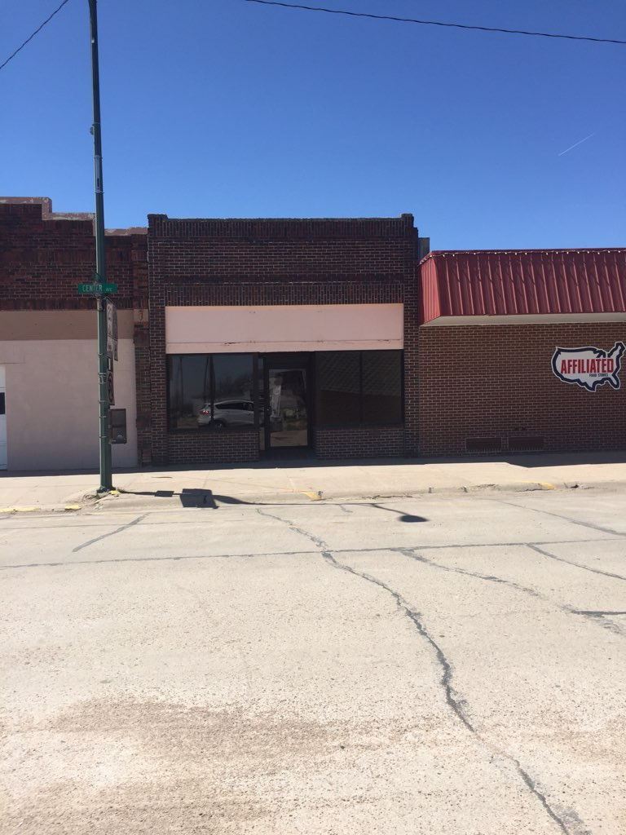

215 Center Ave
Brad Welch - (308) 367-7006 - 10x15 office space - Rent $250 utilities included

217 Center Ave
Lindsay Far - (308) 3253796 - Lot size 3,458 square feet – dimensions 25x30 750 square feet.
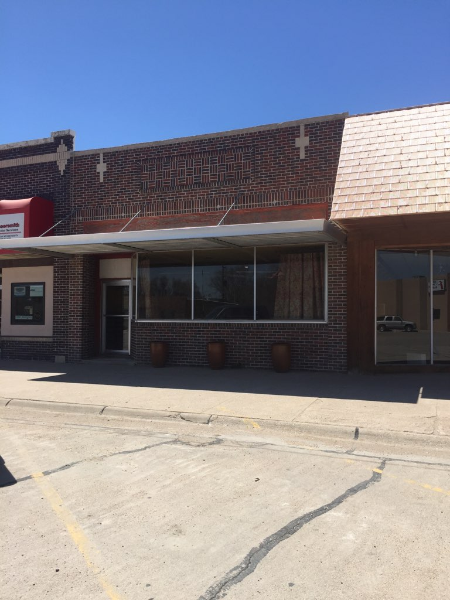

309 Center Ave
Jim Wilkinson - (308) 367-7168 -– lot size 3,500 Square Feet – 60x20 1,200 square feet

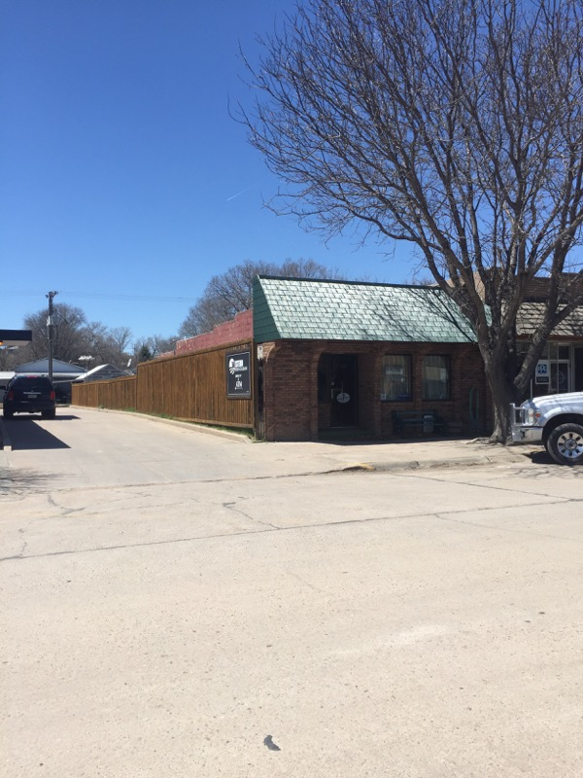

101 W 1st St
Ron Robinson– lot size 10,500 Square Feet – dimensions 38x60 23,000 square feet 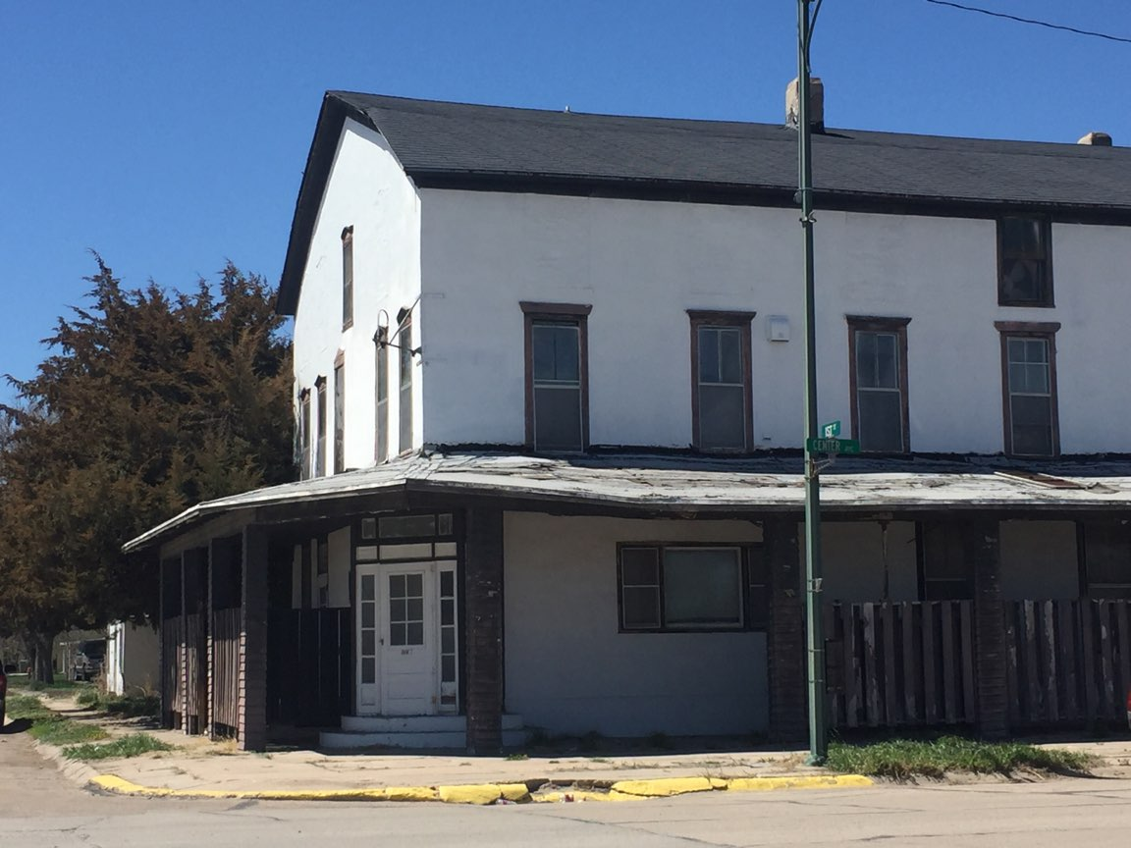

211 Center Ave
Doug Schultz - (308) 367-4122 -– lot size 3,500 square feet – 25x50 1,1250 Square Feet - Rent $350 a month + utilities - Main floor $25,000

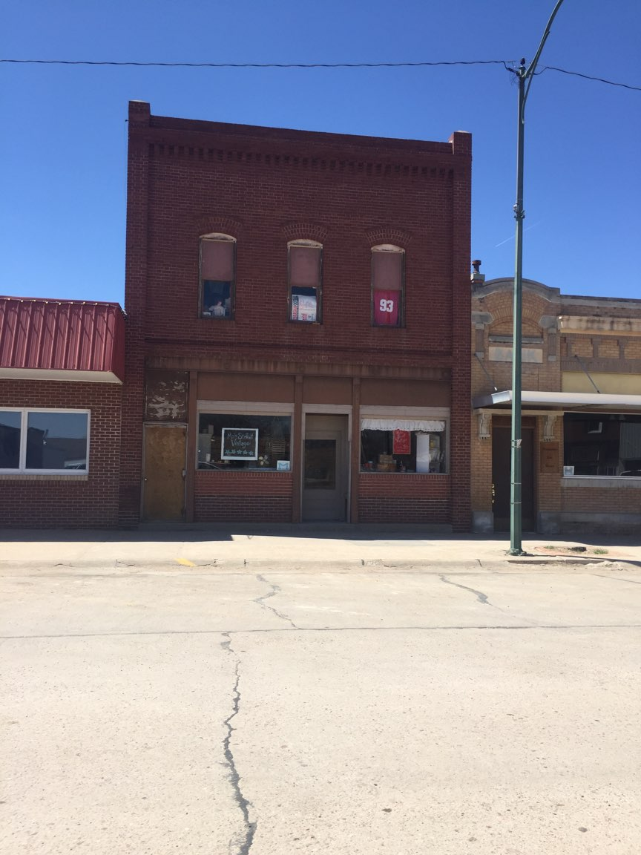

104 W 4th St, Curtis Ne – lot size 5,935 - .14 acres -
Brett and Annette Wood
